Day 7

Exercise 2

Naïve reconstruction

Run “XRMA_matrix_comp.m” with $N=16$. Matrix A is sparse matrix:
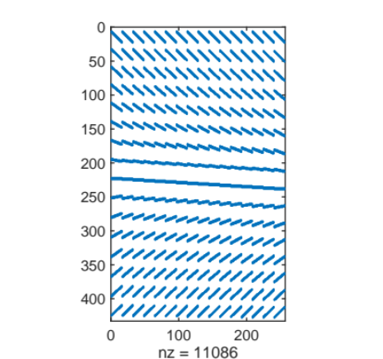
Data with crime and without crime are shown in the below figure. The absolute differences are shown in the right figure.
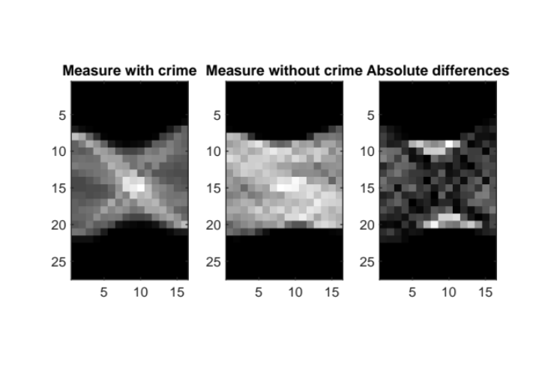
Naïve reconstruction of data with inverse-crime and without inverse-crime is shown in the below figure. We can see that the results are useless in case the measurement has noise.
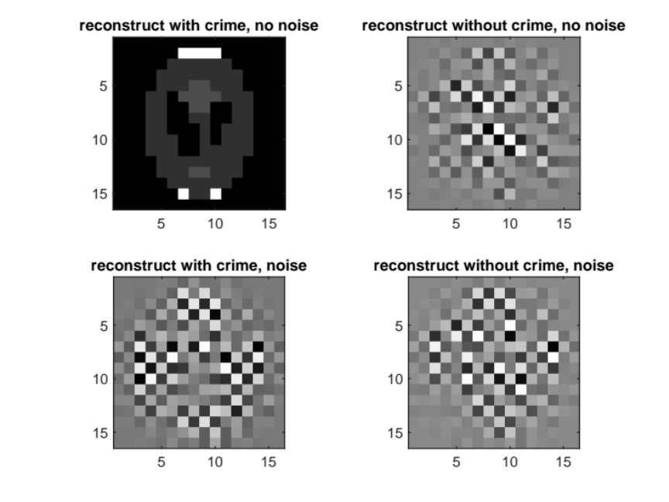

TSVD
Decompose A to [U S V]. The decay of singular values is shown in below figure. The singular value decrease dramatically from the element 160.
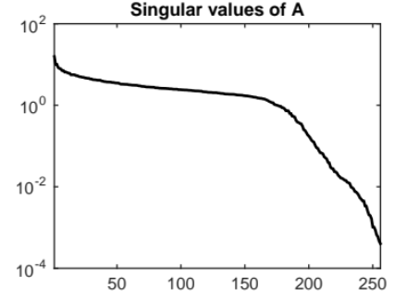
Picard plot: The decay speed of singular value $σ_{i}$ and $\left|\left\langle u_{i}\right.,\left.b\right\rangle \right|$. We can see that the Picard condition break after around $k=150$, when $\left|\left\langle u_{i}\right.,\left.b\right\rangle \right|$ starts having increase trend.
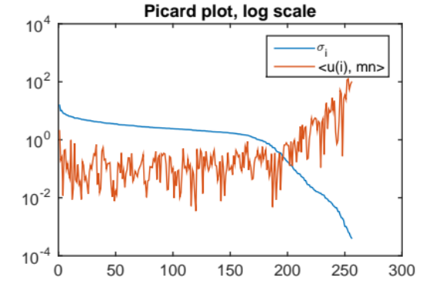
Reconstructed image in relation to number of truncated value
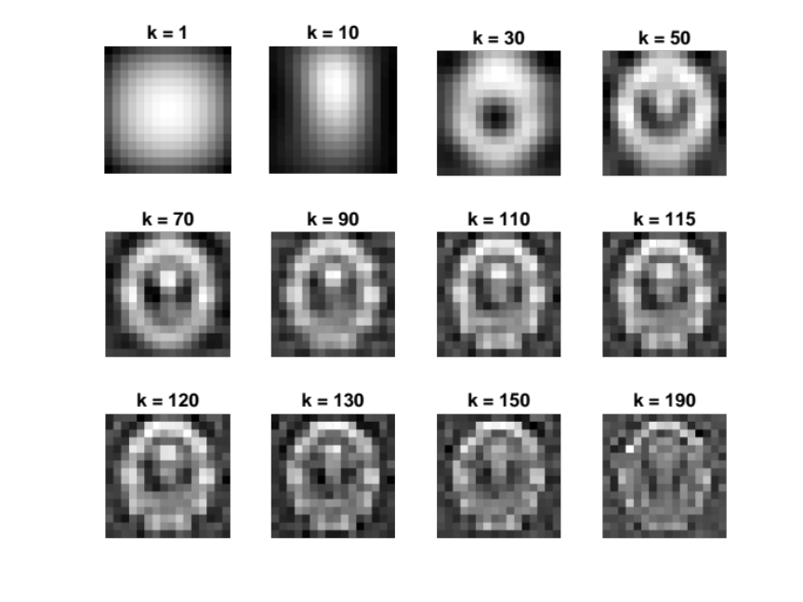
From observation, a good result is reconstructed with truncate value $k\sim 130$. The relative error graph shows that the errors are quite same with $k=30:150$. This may be the results of low resolution of test problem and high noise.
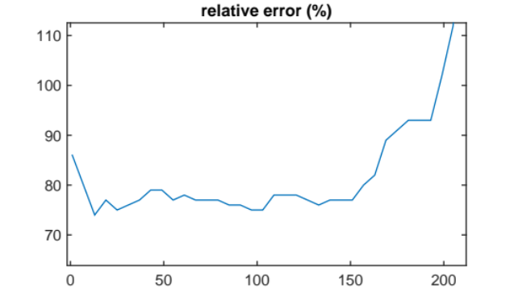

Exercise 3

Simulate tomographic data
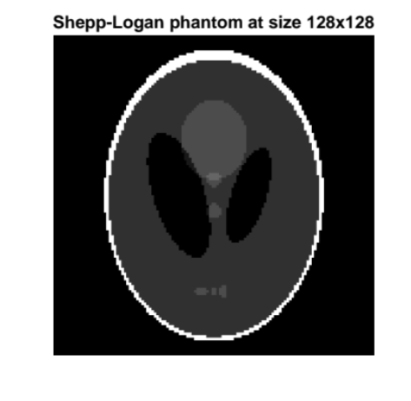
Dummy data
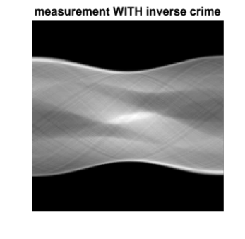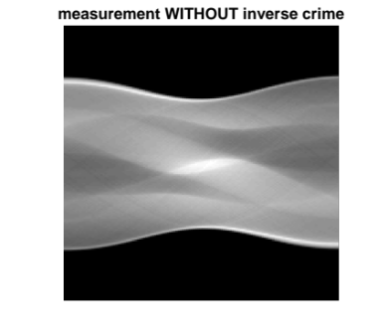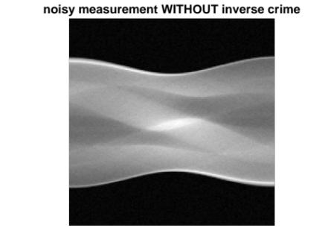
Dummy measurement

Reconstruction using back-projection
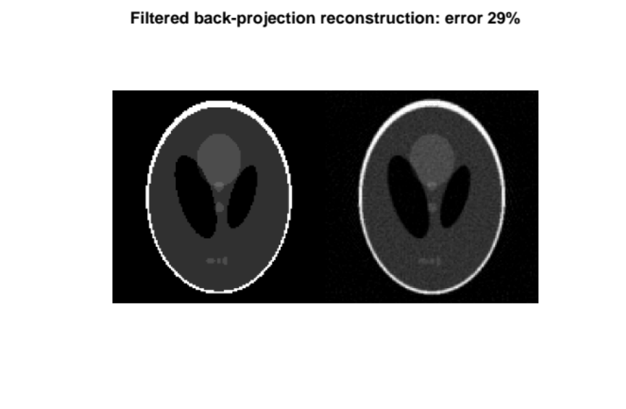

CGLS
Modify cgls

